**Input data**:-

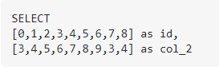

**Expected output data**:-

